Create a Github account:

1. Navigate into the below link provide to create a new Github account and then click on the Sign Up button at the top of the page.

[GitHub · Build and ship software on a single, collaborative platform · GitHub](https://github.com/)



1. Enter the email id to create a new github account and then click on continue button. 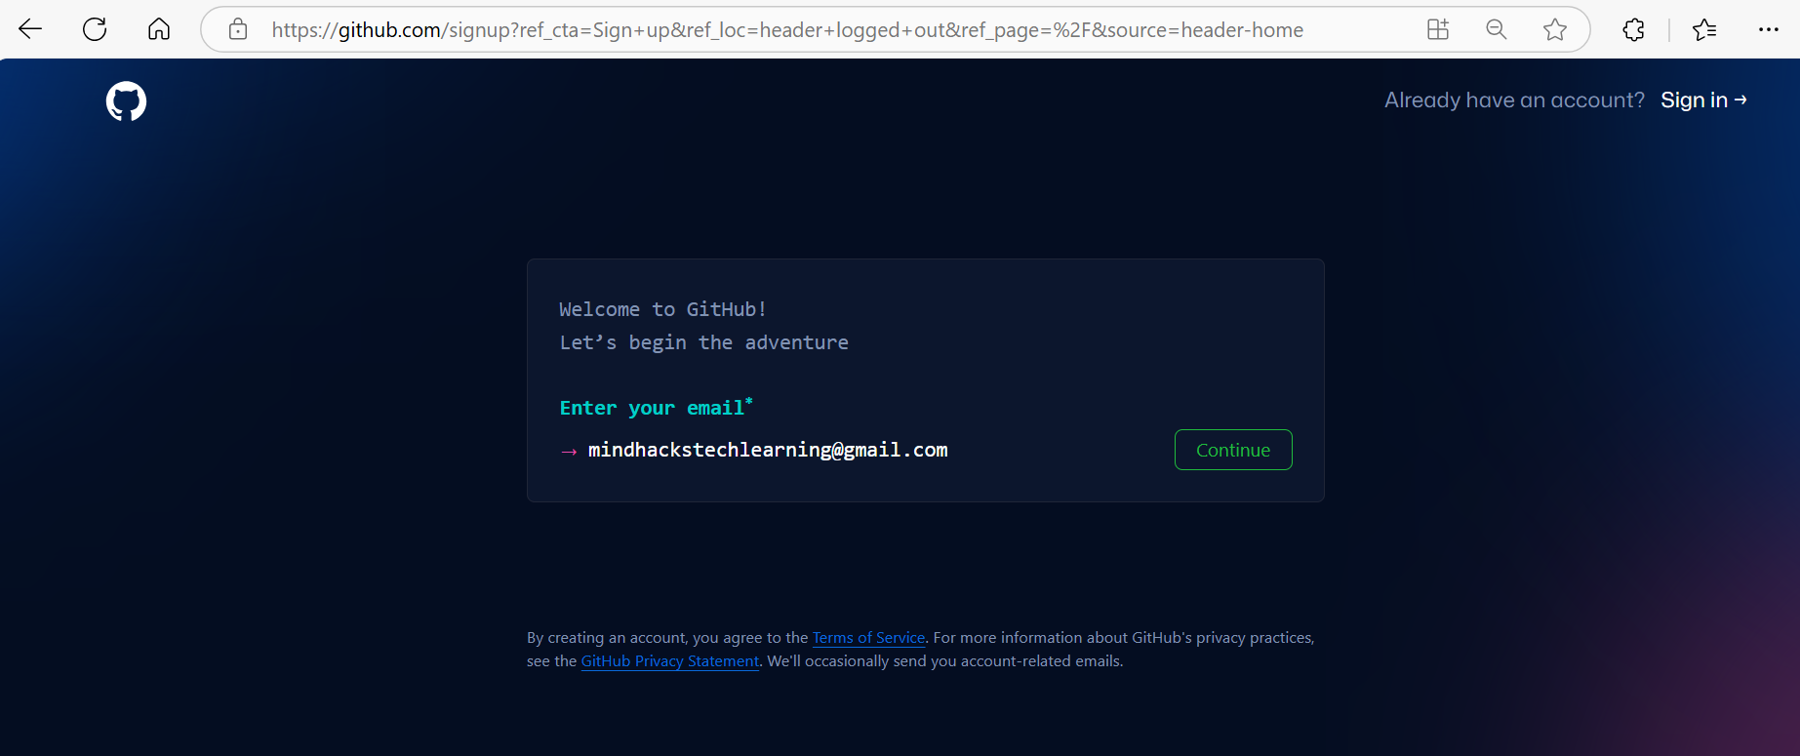
2. Enter the password for the github account to be configured and then click on continue.

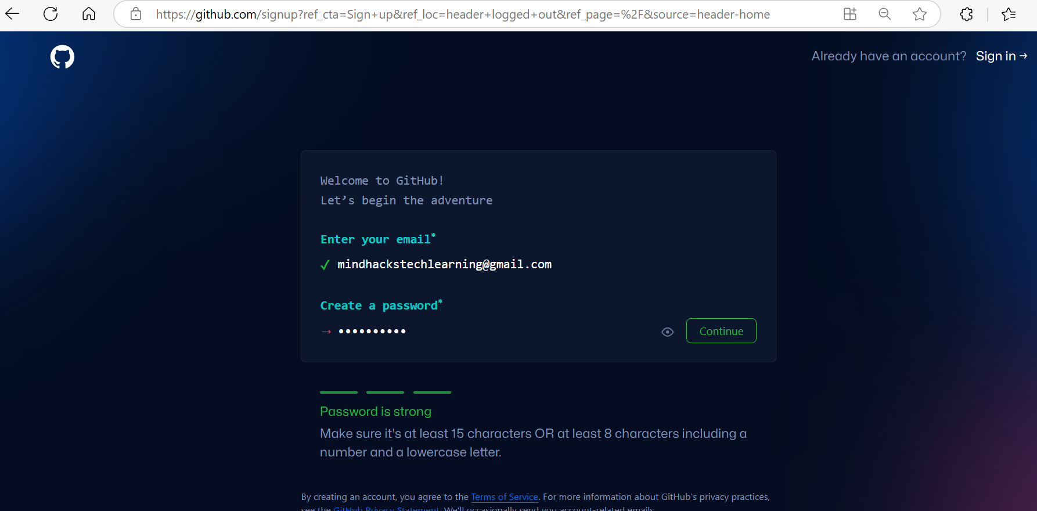

1. Enter the username for the github account and then click on continue button.

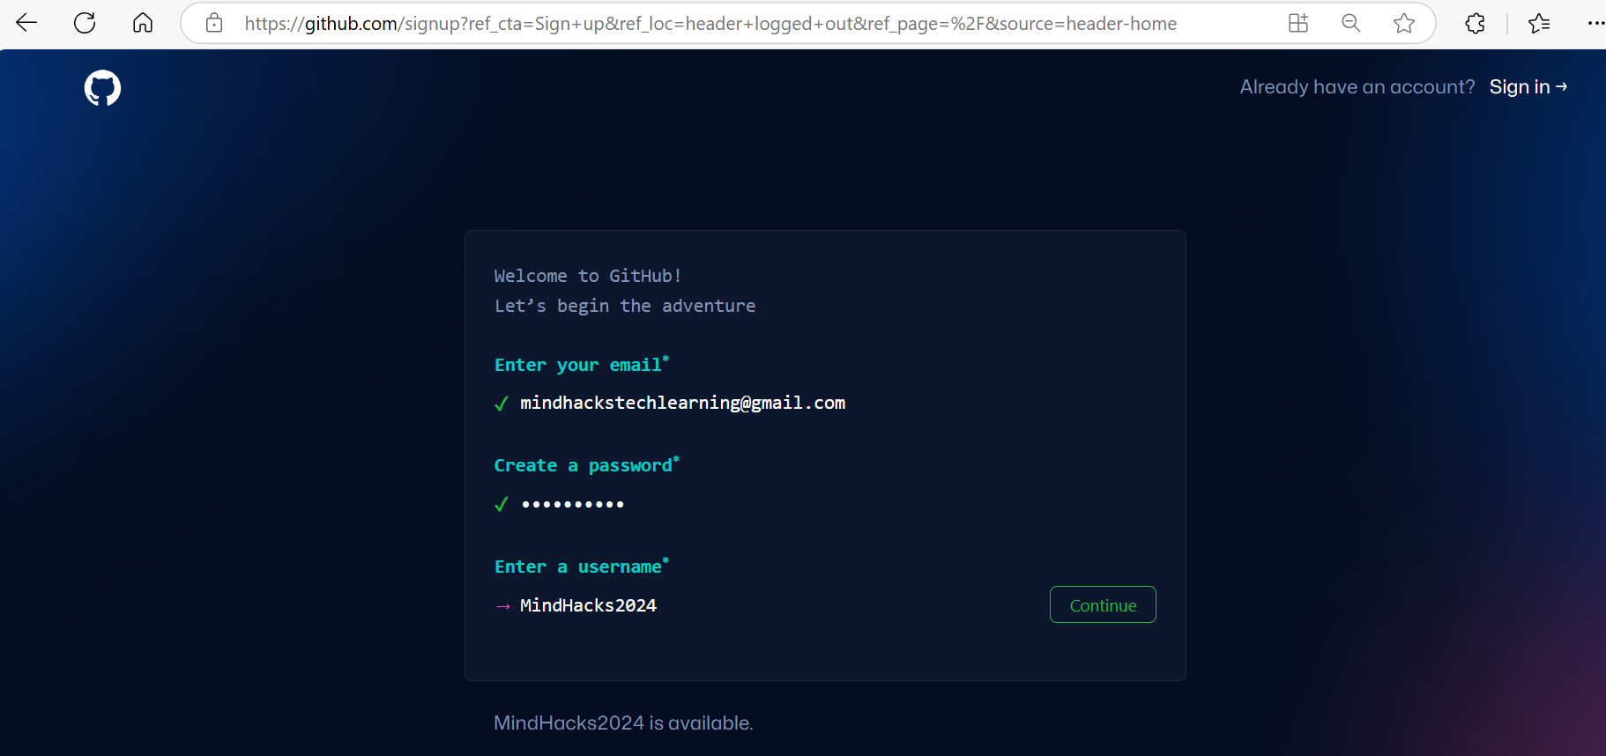

1. Verify the account.

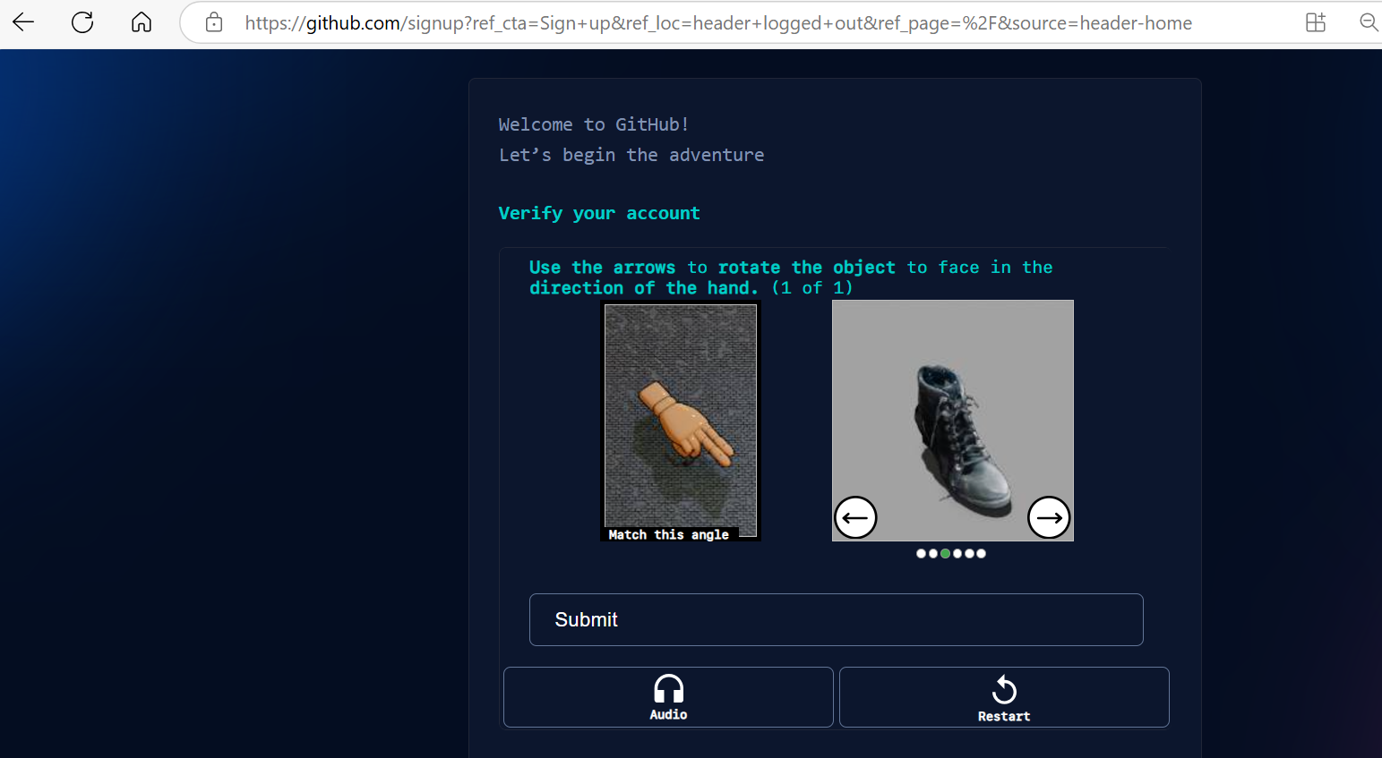

1. Enter the passcode send into your email id and then click on submit button.

The github account will be created successfully.

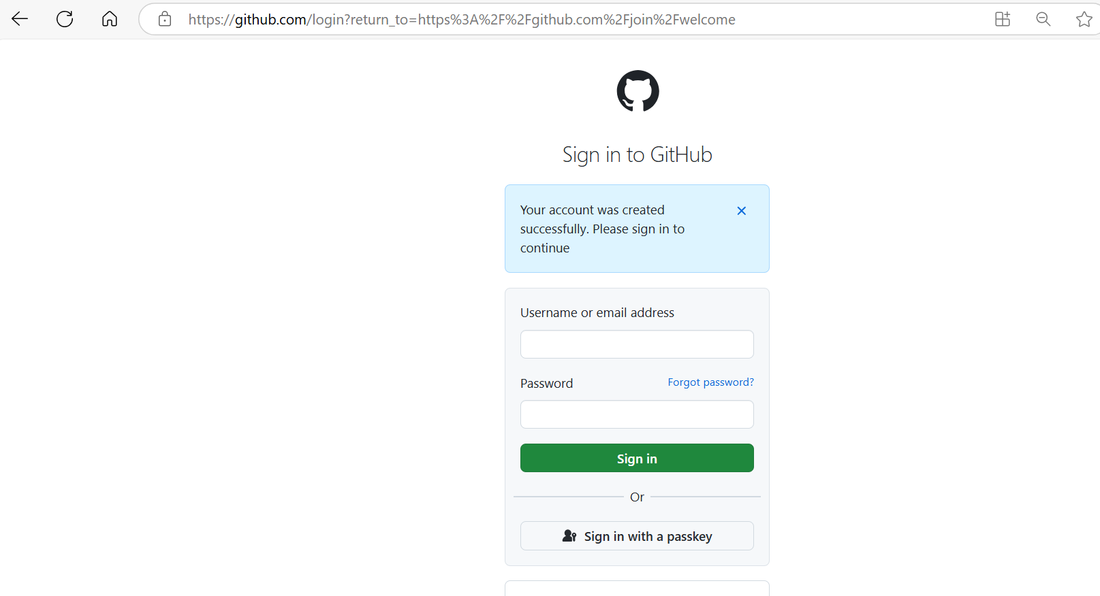

1. Enter the username and password, click on signin button.

Enter the details asked which suites for your designation and then click on Continue button.

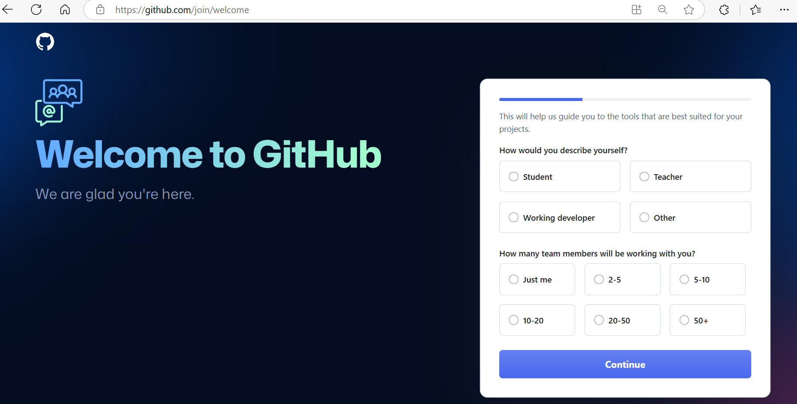

1. Enter the below details specific to your requirement and then click on Continue button.

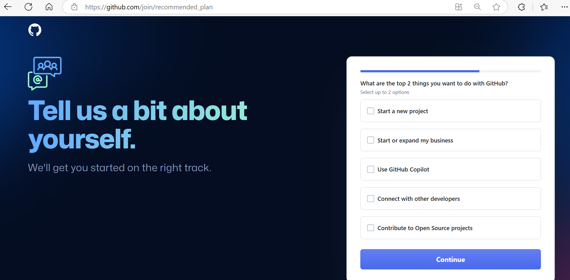

1. Select the ‘Continue for free’ button.

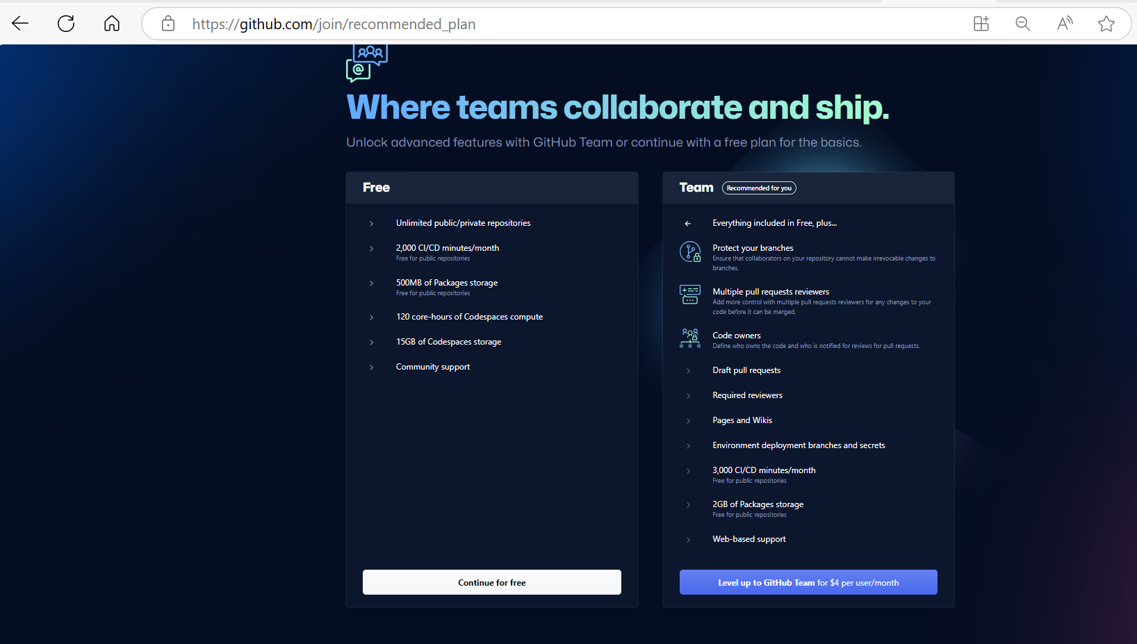

1. The github account will be created successfully.

